**Multiplexed Scanned Temporal Focusing (MuST) Manual**

**Version 1.0**

Date: 02/21/2019

*written b­­­­y Siegfried Weisenburger*

This manual provides a step-by-step guide to get the Multiplexed Scanned Temporal Focusing (MuST) setup.

**Contents:**

1. Beam path
2. Alignment procedure
3. Daily operation
4. Specifications and parameters
5. Troubleshooting
6. **Beam path**

Overview of the beam path on the optical table:

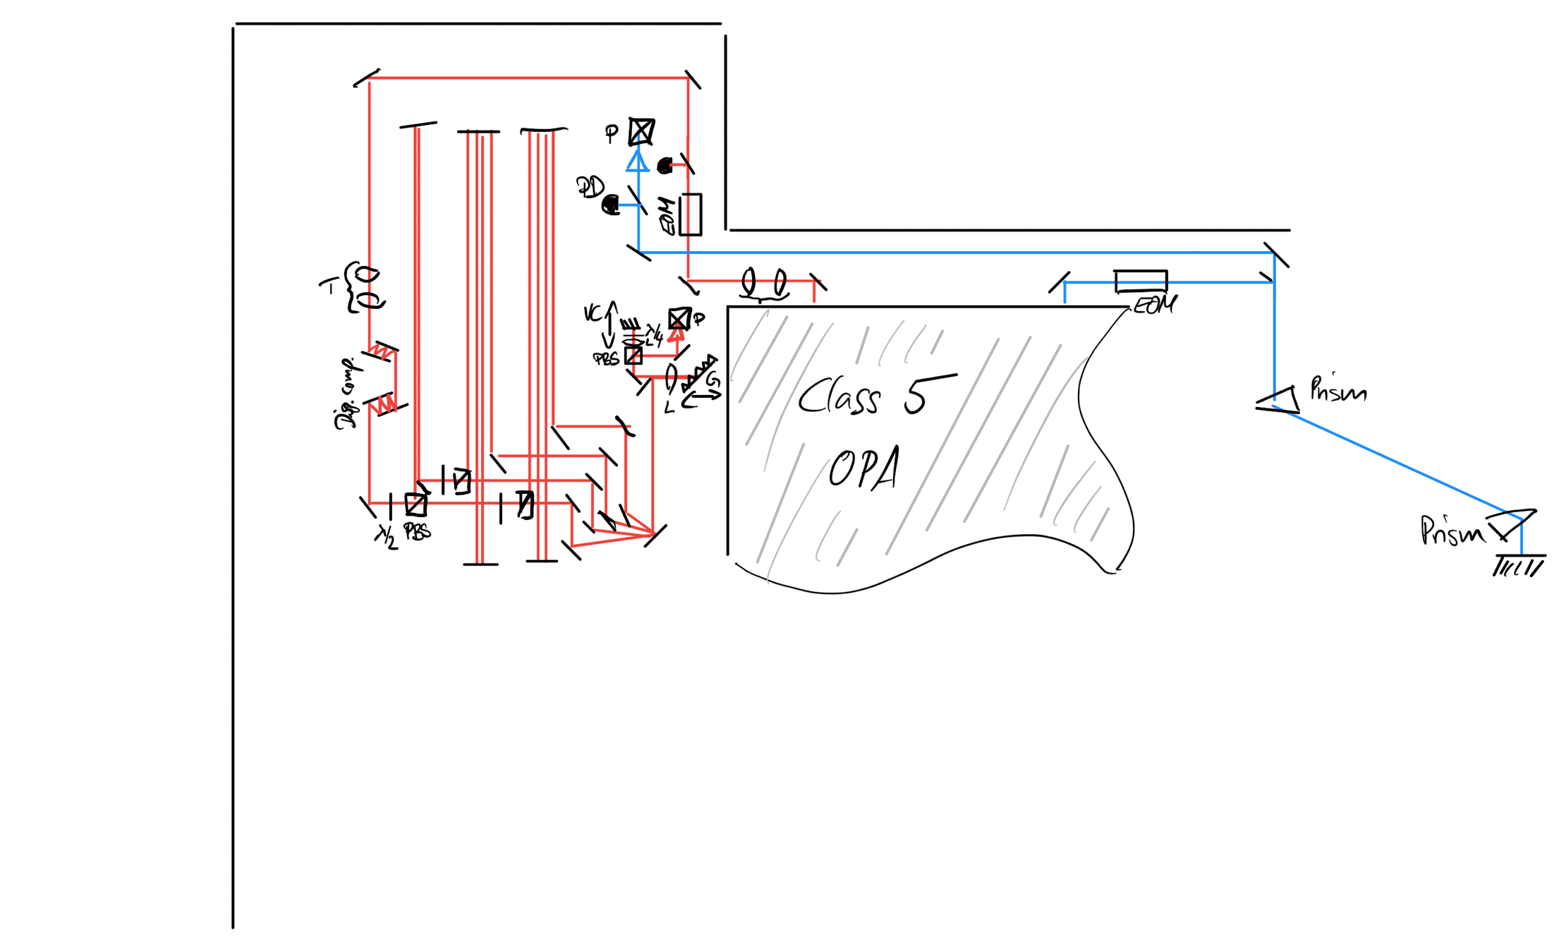

Red: 2p excitation beam, blue: 3p excitation beam. EOM: Pockel’s cell; PD: photodiode; T: telescope; l/2: half wave plate; PBS: polarizing beam splitter; L: lens; G: grating; VC: voice coil; P: periscope to the breadboard.

Overview of the beam path on the breadboard:

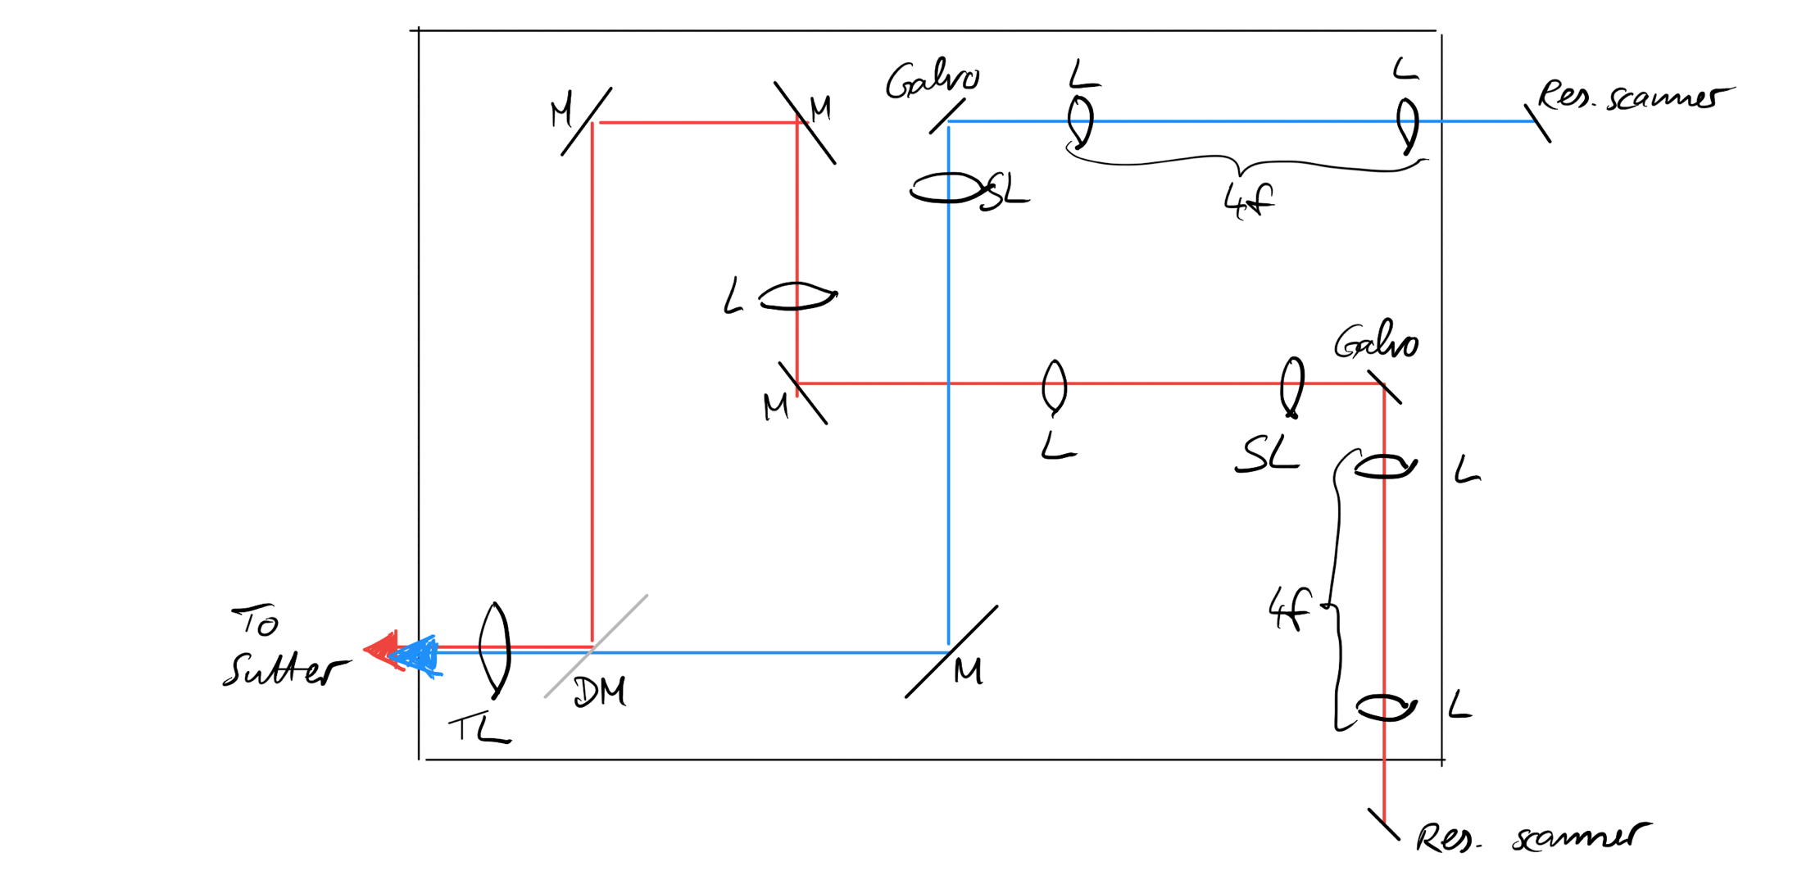

Red: 2p excitation beam, blue: 3p excitation beam. L: lens; SL: scan lens; M: mirror; DM: dichroic mirror; TL: tube lens.

1. **Alignment procedure**

*2.1 Two-photon path*

|  |  |
| --- | --- |
| **Step 1**  Align the 2p beam with the first two mirrors after the Pockel’s cell onto the two irises behind the aluminum shield before the chirped mirrors |  |
| **Step 2**  Check the alignment of the 2p beam through the chirped mirror pairs.  There should be 7 bounces for pair #1 and 6 bounces for pair #2  Example calculation for chirped mirror distance D:  Target: 7 bounces (5 mm separation), 10 degree angle of indicidence => D = 2.5 mm/tan(5) = 28.5 mm |  |
| **Step 3**  Align the beam using the mirror after the chirped mirror pairs onto the hole line using the close iris and the iris at the far end (remove for this purpose the mirror for beamlet 1 on the magnetic mount) |  |
| **Step 4**  Align the other three beamlets by adjusting the PBS mounts using the respective irises for each beamlet delay path.  If the beam is well aligned in Step 3, this should not require repositioning of any optical elements. |  |
| **Step 5**  Align the four beamlets into the temporal focusing module using the D-shaped mirror.  To achieve this: Align the beamlets such that all overlap at the iris marking the conjugated plane to the diffraction gratings. At the same time, the beamlets should have the desired separation on the diffraction gratings to achieve the desired separation in the sample plane.  For example:  4x axial multiplexing, goal is minimal separation. Realistically: 2 mm separation on the mirror before beam crops => 2mm * 6/10 = 1.1 mm separation of the spots on the grating (=> < 100 µm offset in the sample plane) |  |
| **Trick:**  Use Zemax to calculate the separation of the input beamlets at a defined plane and use this for the alignment:  Beams need to overlap at BFP of the f = 100 mm lens and be at about 5 mm separation 200 mm before that conjugated plane:  A picture containing wall, indoor  Description automatically generated  Use a Thorlabs camera at the grating position to verify the beamlet separation in the grating plane. |  |
| **Step 6**  Align diffraction gratings (Littrow configuration for first diffraction order) such that the TeFo beamlets go above the D-shaped mirror and into the remote scanning module. | A picture containing indoor, object  Description automatically generated  (Only two beamlets shown for clarity) |
| **Step 7**  Position and align the voice coil actuator such that the four beamlets hit the desired mirrors and are reflected back. | A close up of electronics  Description automatically generated  The voice coil is mounted on a modified mount from the 2pRAM, axial position as well as pitch can be adjusted |
| **Step 8**  Use the PBS and the 2” square mirror to align the beamlets into the microscope.  For this purpose, position a cage mountable target on the cage to define alignment points. |  |
| **Step 9**  Align the beamlets onto the resonant scan mirror using the upwards pointing mirror in the cage cube. If all planes are correctly conjugated and the beamlets are parallel in the grating / remote scanning plane as well as all on the same spot overlapping in the plane conjugated to it, they should all overlap and look ‘as one’ on the resonant scanner mirror. |  |
| **Step 10**  Check if the beamlets are aligned through the microscope on the breadboard using cage mounted targets.  Trick: It can be easier for the eye to do the alignment with the resonant scanner on.  **Always use the pointing function in ScanImage, otherwise the null position of the galvo scanners is undefined!** |  |
| **Step 11**  Verify the alignment of the beamlets into the Sutter microscope. If adjustment is required, use the last two mirrors before the 2p/3p combination dichroic for alignment with the short alignment tip and the position in the backfocal aperture of the microscope objective as reference points. |  |
| **Step 12 (later)**  With a test sample, optimize temporal focusing by adjusting the gratings (axial position and incidence angle) slightly. |  |

* 1. *Three-photon path*

|  |  |
| --- | --- |
| **Step 1**  Verify the alignment of the 3p beam through the prism compressor. The reflected dispersed beam should be on top of the ingoing dispersed beam.  Using the 0 degree of incidence back-reflection mirror, align the pre-compressed beam onto the first iris. |  |
| **Step 2**  Using the irises next to the 2p Pockel’s cell and the iris mounted on the cage cube for the 3p path, align the beam. |  |
| **Step 3**  Align the 3p beam onto the resonant scanner mirror using the upwards pointing mirror in the cage cube.  Note: The 3p beam is purposefully not collimated with the second telescope after the prism compressor. Collimation is adjusted such that the focal plane is shifted as much as possible below the native focal plane while keeping the spot size on the resonant scanner mirror within the mirror size. |  |
| **Step 4**  Verify alignment through the microscope using cage mounted targets. |  |
| **Step 5**  Verify alignment into the Sutter using the tube lens and backfocal aperture of the microscope objective as reference points.  If alignment is required, use the mirror before the 2p/3p combination dichroic and the scan lens (only if absolutely necessary!) to correct. |  |

1. **Daily operation**

*3.1 Turning on the microscope*

Assumption: The AFS-Class5 system is on and running within specs.

Note: There different microscope configurations:

2p only – axial or lateral multiplexing

3p only

Hybrid 2p/3p

Depending on the configuration, some devices do not need to be turned on.

|  |  |
| --- | --- |
| **Step 1**  Turn on all devices:   * 2p photodiode * 3p photodiode * Voice coil driver (for 2p only configurations with remote scanning) * Objective piezo driver (for 3p only and hybrid configurations, switch is on the back of the device) * Sutter controller (after turning on, press “Move” to enable the joystick control) * PMT power supply (**Do not engage PMT control voltage when the room lights are on!**) * Pockel’s cell driver for 2p beam (bias voltage should be 134 V) * Pockel’s cell driver for 3p beam (bias voltage should be -46 V) * Resonant scanner driver (Leave toggle in oscillator position) * Galvo power supply (24 V bipolar) |  |
| **Step 2**  Turn BNC switches to MuST setting.  Depending on configuration:  Use resonant scanner driver channel A (3p only or hybrid) or channel B (2p only) sync output. |  |
| **Step 3**  Start ScanImage and load the desired configuration including (MDF, DAQ channel, user settings).  Possible issues:   * Pockel’s cell calibration curve outside of specs => Check alignment through Pockel’s cell * Cannot connect to a device => Check if it is on and check cables | A screenshot of a computer  Description automatically generated  ScanImage interface example |
| **Step 4**  Use pollen sample to confirm:   * TeFo alignment, can be optimized for signal by adjusting the axial position and angle of incidence (rotation) of the diffraction gratings * Sequence of multiplexed beamlets and FOVs (NI Sample configuration) * Overlap of FOVs |  |
| **Step 5**  If using the objective piezo:  Confirm axial scanning waveform, if necessary, make adjustments of PID settings and notch filters in NPoint software.  Fly back time should be < 35 ms. |  |
| **Step 6**  If using hybrid mode:  Let resonant scanners warm up for a few minutes. Then switch from (freely) oscillating (**osc.**) mode to (phase) **locked** mode. The two resonant scanners are now phase locked and only channel A (master) sync output is used by ScanImage as line sync signal. |  |

1. **Specifications and parameters**

|  |  |
| --- | --- |
| Remote scanning calibration for lateral multiplexing (f = 40 mm remote scan lens)   * Calibration in MDF |  |
| Remote scanning calibration for axial multiplexing (f = 60 mm remote scan lens)   * Calibration in MDF |  |
| Axial extent of TeFo beam: ~ 15 µm |  |
| ACF for the 2p excitation through the entire setup (+ additional f = 30 mm achromat and three Ag mirrors, accounting for additional 1,100 fs2 of dispersion => ~100 fs) using the chirped mirror pairs. |  |
| ACF for the 3p excitation through the entire setup (+ additional f = 30 mm achromat and three Ag mirrors, accounting for additional 1,100 fs2 of dispersion => ~100 fs) using the prism compressor. |  |
| Concept for exponential power adjustment in axial multiplexing.   * I usually tried to match the actual curve with the second or third segment. |  |
| Example 2p Pockel’s cell calibration curve.  Aim for >300 extinction ratio.  For the 3p Pockel’s cell the extinction ratio is lower, aim for > 100. |  |

1. **Troubleshooting**

*Scan phase instability:*

This issue can appear and is likely caused by the laser beam heating the base of the resonant scanner. It appears also to be correlated with draft of cold air from the AC, I have observed better and worse days. A way to minimize the issue is to let the resonant scanner settle with the shutter open (use something to block the beam entering into the Sutter). One can then ‘manually’ shutter the beam shortly before the acquisition starts. Exposure to the beam for a short while is ok if the scanners are kept on and the beam does not stand still.

*Immersion water wetting issue:*

I sometimes had the issue that a hair of the mouse or a contamination of the cranial window caused the surface tension of the immersion water to break. In this case, the best thing to do is just to clean both window and objective with alcohol and let it dry well for 1-2 minutes before applying any new immersion water (fresh start).

*Axial extent of TeFo spot:*

Most likely an alignment issue. Is the alignment for signal with the diffraction gratings (axial position and angle of incidence) optimized? If the issue persists: Check first by inspecting the filling of the back aperture of the microscope objective. Is the beam in the dispersed direction clipped? Trace through the microscope and adjust alignment.

*ScanImage issues:*

* I sometimes had issues with slow stacks when not using a symmetric stack.
* There is a problem when doing a volumetric recording with a large number of planes (~100), the volume adjust can run out of phase with the acquisition causing skipped frames – there is no error during the acquisition, but planes will be missing in the recorded file.